**Obituary: Antonin Scalia**

**讣告：安东尼·斯卡利亚**

（英文部分选自经济学人20160220期讣告）

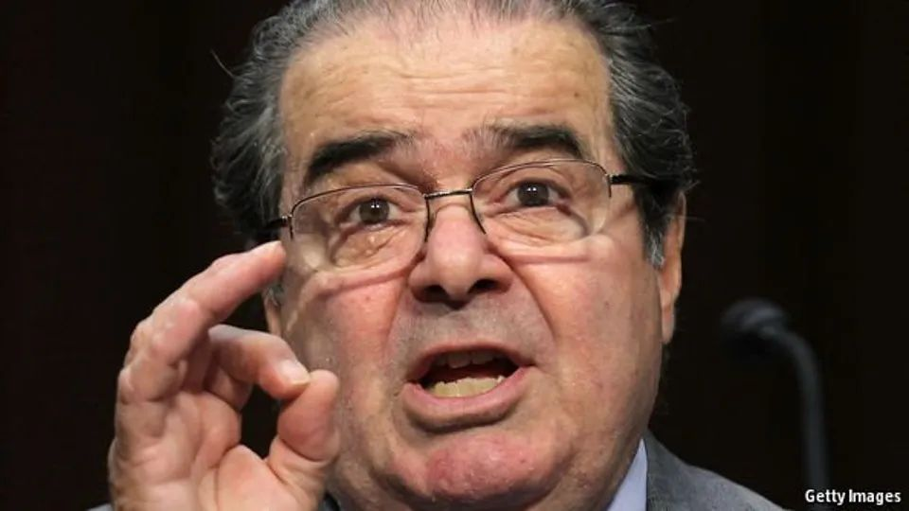

Always right

永随本真

Antonin Scalia, Supreme Court justice, died on February 13th, aged 79

最高法院大法官安东尼·斯卡利亚于2016年2月13日逝世，享年79岁

1. IF YOU were bold enough to ask Antonin Scalia questions, you had to be precise. Otherwise the bushy black brows would furrow, the chin would crumple and the pudgy, puckish body would start to rock, eager to get at you. Wasn’t he violently opposed to Roe v Wade, the abortion ruling? “Adamantly opposed, that’s better.” Did he have any guilty pleasures? “How can it be pleasurable, if it’s guilty?” Lesser lawyers who were vague in oral argument faced a barrage of sarcasm or, if he agreed with them, constant chiding to do better. (“That’s your strong point!”) Dissenting colleagues at the Supreme Court had their opinions described as “argle-bargle”, “jiggery pokery” and “pure applesauce”.

若你够胆向安东尼·斯卡利亚（Antonin Scalia）提问，问题就必须精准。否则，他就会浓眉紧锁，下巴扭曲，胖胖的身躯恶作剧般开始摇晃，随时准备着数落你。当问到他是否强烈反对罗伊诉韦德案（堕胎权）的裁决时，他表明：“应该说我是坚决反对（堕胎合法化），这样形容更妥帖。”当问到他是否也有一些不良的小嗜好时，他便答道：“既为不良，如何能嗜？”当后辈律师在口头辩论时表述含糊，要是斯卡利亚不同意他们的观点，则会甩出一大堆讥讽；若是同意他们的观点，斯卡利亚也会不停地责问，促使他们进步。（“这是你的得分点！”）。对于其他观点向左的大法官，他会把他们的意见形容为“长篇大论”、“胡搅蛮缠”和“纯粹胡言乱语”。

②Words had meaning. He revered them and used them scrupulously, even in insult. The law was written in words, and those ideally laid down bright lines for everyone to follow. As a committed textualist, he wasted no time looking to legislative history, the purported purpose of a law or the comments of some egregious congressman. It meant what it said.

词语都是有含义的。斯卡利亚敬重语言，遣词造句上非常谨慎，哪怕是在讽刺揶揄，也准确严谨。法律是由文字书写的，而这些已经形成的法律条款就是让所有公民遵守的。作为一个坚定的文本主义者，斯卡利亚从不浪费时间探寻立法历史，也不会去研究一条法律形成的缘由，对一些品行不端的国会议员的评论更是不予理会。法律条文字面上是什么，就是什么。

③As for America’s constitution, speaking as the court’s originalist-in-chief, all that mattered was what its words meant when it was framed. He was in love with it; he was in awe of the men who wrote it; the late 18th century was a time when genius burst forth on the eastern seaboard, as it had in Periclean Athens. But for him the founding document was not “living”, not some organism endlessly adaptable to society, as Justice William Brennan, a distressingly liberal predecessor, used to think. It couldn’t be found suddenly to contain newfangled “rights” to privacy, as in Roe. It was dead! Dead! (Or perhaps, to be more tender and precise, “enduring”.) Its business was to block change, not advance it, and if it thereby obstructed something he himself, as a very conservative fellow, disliked, so much the better. Death-penalty cases he dismissed in minutes: the penalty was clearly constitutional. Church-and-state cases took no longer: the Framers had built no wall between them, and anyway, didn’t government get its authority from God? He would go home, to a Martini and a large dinner, and sleep like a baby.

谈到美国宪法时，斯卡利亚作为联邦最高法院最主要的原旨主义者，坚持按照美国宪法制定时的字面意思理解宪法。他推崇宪法，也敬畏宪法的制定者；18世纪末期的美国东部沿海地区就像伯里克利的雅典时期那样人才辈出。但对斯卡利亚来说，宪法不是“鲜活的”。笃信自由主义的前任大法官威廉·布伦南（William Brennan）认为宪法是一个在不断适应社会的生命体，斯卡利亚则不予认同；他认为宪法中所说的“权利”不可能包含新出现的“隐私权”，正如罗伊案中提到的那样。宪法是死的！是死的！（更委婉准确的说法或许是“永恒的”)。宪法意在阻止而非推动变动。如果因为遵循宪法的原旨而阻挡了一些变革，而这些变革又是斯加利亚这个典型的保守派所不接受的，那是最好不过了。他能在几分钟内就驳回死刑案件，因为死刑没有违背宪法。审理关于教会与国家的案件也无需太长时间，因为制宪者并未在二者间筑墙，更何况政府的权力不正来自上帝吗？他回到家，喝上一杯马提尼，吃一顿丰盛的晚餐，然后如婴儿般睡去。

④The beloved document, however, never promised perfect outcomes. In 1989 he found himself ruling (joining Brennan!) that it didn’t stop sandal-wearing bearded weirdos burning the American flag. (Personally, he would have clapped them all in jail; he longed to mark his opinion loudly with a rubber stamp, “Stupid but Constitutional!”) In several cases the constitution enhanced, rather than curbed, the rights of criminal defendants and terrorists. He did what he had to do. This made him a less predictable justice than many supposed.

美国宪法尽管广受尊崇，却并不意味着一定会产生完美的好结果。1989年，斯加利亚裁定（居然和布伦南意见一致！）宪法并不阻止穿着人字拖、留着大胡子的怪人焚烧美国国旗。（就他个人而言，如果把这些人能全部都关起来，他会拍手叫好。他一直希望在他的观点上加盖一个橡皮印章，上面写着“愚蠢但是合乎宪法”。）在一些案件中，宪法甚至伸张而不是限制了罪犯、恐怖分子的权利。他做了他不得不做的事。不以个人好恶而完全依照宪法的做法使得他的裁决更加让人难以揣测。

⑤More often, the document said nothing at all about some modern obsession: torture, abortion, discrimination. But then such matters, as Justice Scalia kept saying, were never meant to be settled by an unelected committee of nine; they were meant to be resolved by the people, through legislation. If he were a king, as his swagger and opera-singing occasionally suggested, he would stretch the constitution any way he wanted. In fact, as he admitted with a grin, it handcuffed him.

更多情况下，美国宪法对如何处理现代社会的很多问题没有提及，比如：虐待、堕胎还有种族歧视。但斯卡利亚法官一直强调，即使这样，如何处理这些问题也不应该由未经选举的九人法官团来决定，而应该让人民大众通过立法来解决。要是他是个国王，他会任由自己的性子来改动宪法，就像他偶尔唱歌剧时剧中的角色那般狂妄。事实上，他总是笑着承认他自己是受制于宪法的。

⑥Not nearly enough, some people thought. His colleagues quailed when, in 1986, he first sat on the court as a brash 50-year-old whose experience had been mostly as a combative government lawyer: a justice who, in that sanctum of columns and deep judicial silence, was suddenly firing questions like grapeshot. (As the product of a Jesuit military academy, as well as an originalist, he loved to evoke cannon and muskets, and much enjoyed duck-shooting; he talked of tracking truth like a hunter in the forest, and was pleased to rule, in District of Columbia v Heller, that the Second Amendment did indeed mean that individuals had the right to bear handguns.) Though he was not the only New Yorker on the bench, he was the only spoiled-rotten Italian kid brought up proud and scrapping in Queens and familiar with rude Sicilian gestures. “Come right back at you!” was his motto, robed or not.

有人认为他还远远不止如此。1986年，50岁一身傲气的斯卡利亚成为了最高法院的法官，而他的职业生涯中大部分时候都是一名好斗的政府律师。而作为一名大法官，在最高法院的法庭上，他连珠炮般地发问，打破了司法机关的沉默，也震惊了他的同僚。（出身于耶稣会军事学院，做为一名原旨主义者他喜欢火药味儿，乐于“射鸭游戏”；他谈论起自己追寻真理就像猎人在森林中一样。在哥伦比亚特区诉海勒案中，根据第二修正案，个人有权持枪，他乐于如此裁决。）虽然他不是唯一一个来自纽约的大法官，但他是唯一一个在皇后区长大，被宠坏的意大利裔大法官，从小傲娇爱打架，还熟悉粗鲁的西西里手势。不管穿不穿大法官的袍子，“我等会就来治你！”是他的座右铭。

⑦Family-fond (nine children!), gregarious and funny, he got on with his colleagues, and made a surprising best buddy of the court’s chief liberal, Ruth Bader Ginsburg. But he spared no ammunition in dissent. As early as 2003, when Lawrence v Texas struck down sodomy laws, the majority had “signed on to the…homosexual agenda”. In 2015, when the court narrowly saved Obamacare, “We should [call] this law SCOTUScare.” He never tried for consensus, not rating it anyway, and increasingly sat with the minority, though always the most colourful and quotable.

斯卡利亚是个喜欢和人打交道、有趣又顾家（有九个孩子！）的人，和同事相处融洽；出人意料的是，他和最高法院主要的自由派大法官鲁斯·巴德·金斯伯格（Ruth Bader Ginsburg）的关系非常铁。但在表达反对意见的时候，他也毫不留情面。早在2003年，劳伦斯诉得克萨斯州案宣判，非自然法性行为非法的规定成为历史，当时他就说法院的多数法官“认可了……同性恋的议案”。2015年，最高法院勉强保住了奥巴马医改法案，而他又说“这个法案应该叫《最高法院医改法案》”。斯卡利亚从不追求共识，也从不对共识做什么评价；他向来是最出彩、意见最有价值的那一个，近来站到少数派一边的频率也越来越高了。